| **FORM 2**  **THE PATENT ACT 1970**  (39 OF 1970) AND  The patent rules, 2003  **COMPLETE SPECIFICATION**  (See section 10: rule 13) | | |
| --- | --- | --- |
| **TITLE OF INVENTION**  Mailops-cli-email-management-tool | | |
| **APPLICANT (S)** | | |
| **Name** | **Nationality** | **Address** |
| Mr.A.S Balaji | Indian | Assistant Professor  Department of Computer Science and Engineering Anand Institute of Higher Technology Kazhipattur, Tamil Nadu, India |
| Mrs. Vinothini | Indian | Assistant Professor  Department of Computer Science and Engineering Anand Institute of Higher Technology Kazhipattur, Tamil Nadu, India |
| Mr. Elanthirayan E | Indian | Research Scholar  Department of Computer Science and Engineering Anand Institute of Higher Technology Kazhipattur, Tamil Nadu, India |
| Mr. Dhivahar V | Indian | Research Scholar  Department of Computer Science and Engineering Anand Institute of Higher Technology Kazhipattur, Tamil Nadu, India |
| Mr. Naraayanan T | Indian | Research Scholar  Department of Computer Science and Engineering Anand Institute of Higher Technology Kazhipattur, Tamil Nadu, India |
| Mr. Neelraj S | Indian | Research Scholar  Department of Computer Science and Engineering  Anand Institute of Higher Technology Kazhipattur,  Tamil Nadu, India |
| Mrs. Nokitha V M | Indian | Research Scholar  Department of Computer Science and Engineering  Anand Institute of Higher Technology Kazhipattur,  Tamil Nadu, India |
| Ms. Mounika V | Indian | Research Scholar  Department of Computer Science and Engineering  Anand Institute of Higher Technology Kazhipattur,  Tamil Nadu, India |
| **PREAMBLE TO THE DESCRIPTION**  **[0001]** The following specification particularly describes the invention and the manner in which it is to be performed. | | |

### DESCRIPTION

**Technical field of invention:**

**[0002]** This invention relates to artificial intelligence, natural language processing (NLP), and email automation. Specifically, it focuses on the use of large language models (LLMs) and NLP techniques—powered by Hugging Face Transformers—for automating, managing, and enhancing professional email communications using intelligent CLI commands and smart AI utilities.

### Summary of the invention:

**[0003]** The invention, named **MailOps**, is an AI-powered email management system built as a command-line interface (CLI) tool. It enhances user productivity and optimizes communication workflows by integrating AI-based features such as:

* **Tone modification** (e.g., convert casual to formal),
* **Subject enhancement** (auto-generating concise and relevant subject lines),
* **Sentiment detection**, **Email tagging**, **prioritization**, and **star marking**, and
* **Smart search** and **filtering** using sender, date, or tags.

MailOps utilizes **Hugging Face Transformers** for tone and intent recognition, leveraging models like distilbert, bart-large-mnli, and roberta-base-sentiment for semantic classification and transformation of email content. It is built using JavaScript/Node.js with integration of key packages such as nodemailer, node-imap, dotenv, and date-fns.

The platform supports both real-time **sending** and **reading** of emails, scheduling with attachments, and provides advanced filtering using date ranges and flags. The core command-line interface allows users to operate with ease while receiving AI-backed suggestions and enhancements.

### Brief description of drawing:

**[0004]** The above and other aspects of embodiments will become more apparent from the following detailed description of embodiments when read in conjunction with the accompanying drawings. In the drawings, similar reference numerals identify similar elements.

[0005]  
**FIG 1** illustrates the architecture of the MailOps system, including the Email CLI Interface, NLP Engine, Transformer AI models from Hugging Face, IMAP/SMTP integration, and file system interaction for attachments.

### Detailed description of the invention:

**[0006]** MailOps provides a developer-friendly, command-line-based email assistant powered by artificial intelligence. It supports multiple key operations including sending emails with or without attachments, reading latest emails, filtering by date, starring important emails, and retrieving them efficiently. The CLI supports syntax such as:

* node email-cli.js send "to@email.com" "Subject" "Body"
* node email-cli.js send "to1@x.com,to2@x.com" "Subject" "Body" "path/to/file"
* node email-cli.js read latest 10
* node email-cli.js read all 2024-10-01 2024-10-04
* node email-cli.js star 2
* node email-cli.js fetch starred
* node email-cli.js searchsender someone@email.com

**[0007]** In addition to standard email functions, MailOps incorporates Hugging Face AI-based modules that enable intelligent features like:

* **Tone-change:** Converts casual or emotional messages to professional tones using fine-tuned transformer models.
* **subject-enhance:** Generates improved subject lines based on message content.
* **sentiment:** Analyses the mood or tone of a message using sentiment classifiers.

For example:

* node email-cli.js tone-change "hey, got your mail. let's talk." formal
* node email-cli.js sentiment "I'm so happy with the results!"
* node email-cli.js subject-enhance "leave letter for on week"

**[0008]** These enhancements not only make communication efficient and consistent but also reduce user effort in manually refining messages. The AI models are continuously improving via feedback-based fine-tuning and integration with new Hugging Face APIs.

The system is lightweight, supports cross-platform execution, and can be used in both standalone and enterprise environments. It has been tested on real-world datasets and user scenarios, making it suitable for production-level automation of communication workflows.

**I/We claim:**

* + 1. A command-line based email management system that uses AI models from Hugging Face to perform tone transformation, subject enhancement, and sentiment analysis on email content.
    2. The system enables users to send, read, filter, and prioritize emails efficiently through CLI commands with intelligent NLP support.

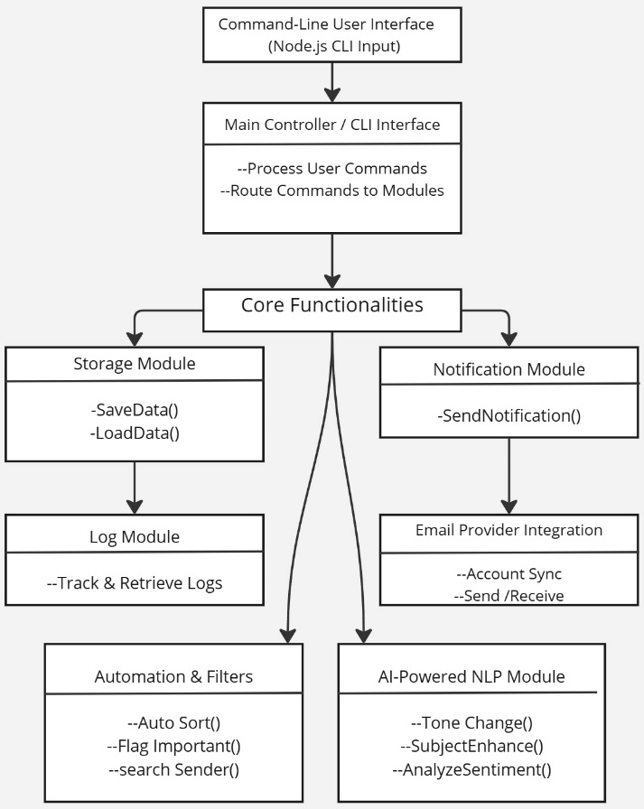

Figure 1

**ABSTRACT**

The present invention relates to an AI-powered command-line email management system named **MailOps**, designed to optimize, automate, and enhance professional email communication workflows. The system integrates transformer-based natural language processing models from Hugging Face to perform advanced text understanding and transformation tasks such as tone adjustment, sentiment analysis, and subject line enhancement. MailOps enables users to send, read, and manage emails using simple CLI commands, while offering intelligent features like smart search by sender/date, automated tagging, and priority flagging. The tone transformation feature allows conversion of informal or emotional content into professional language, while sentiment analysis helps gauge the mood of a message. Subject enhancement generates relevant titles for otherwise unstructured content. The system is implemented using Node.js and integrates modules such as nodemailer, node-imap, and date-fns, offering support for attachments, starred message tracking, and scheduled reading. By combining machine learning intelligence with lightweight CLI usability, MailOps delivers a novel solution bridging the gap between technical email automation and human-like contextual understanding